Axis of a Cylinder
# Source: AI Source: Provided by: [Data Path: Persons Table -> ID Column: 1, Name_En Column: Motasem Essam] -> From: [ChatGPT] on [7/25/2026]
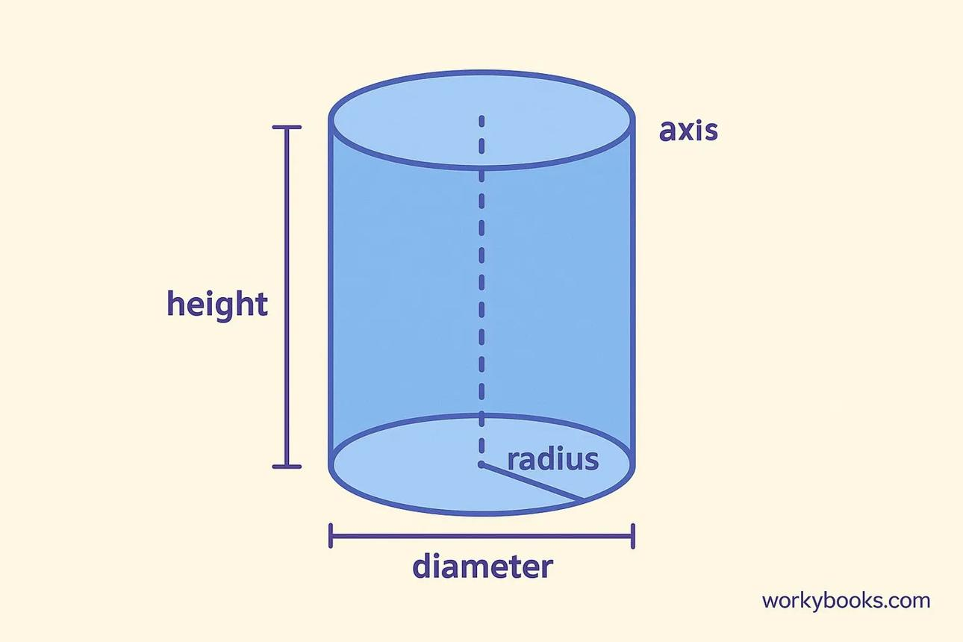
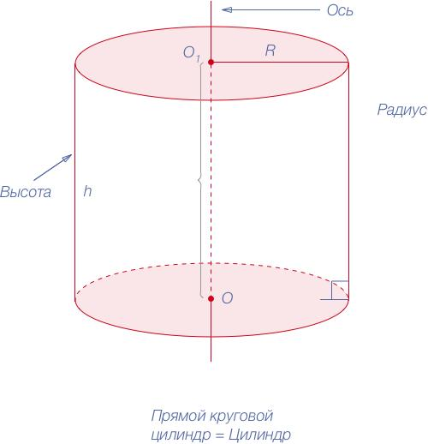
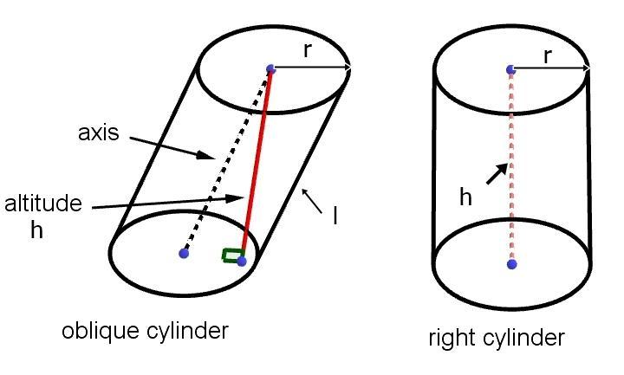

Definition
# Source: AI Source: Provided by: [Data Path: Persons Table -> ID Column: 1, Name_En Column: Motasem Essam] -> From: [ChatGPT] on [7/25/2026]
The axis of a cylinder is the straight line passing through the centers of its two circular bases. It establishes the cylinder's central direction and helps distinguish a right circular cylinder from an oblique circular cylinder.
For a right circular cylinder, the axis is perpendicular to the base planes. For an oblique circular cylinder, the axis is inclined to the base planes.

Simple Definition
# Source: AI Source: Provided by: [Data Path: Persons Table -> ID Column: 1, Name_En Column: Motasem Essam] -> From: [ChatGPT] on [7/25/2026]
The axis is an imaginary straight line running through the centers of the cylinder's two circular bases.
It passes through the center of one base and the center of the other base.

Geometric Representation and Components
# Source: AI Source: Provided by: [Data Path: Persons Table -> ID Column: 1, Name_En Column: Motasem Essam] -> From: [ChatGPT] on [7/25/2026]
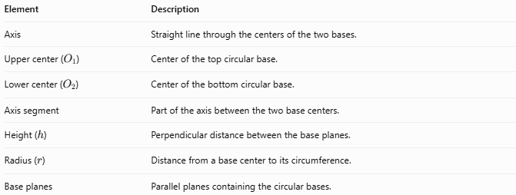
Element | Description
Axis | Straight line through the centers of the two bases.
Upper center ($O_{1}$) | Center of the top circular base.
Lower center ($O_{2}$) | Center of the bottom circular base.
Axis segment | Part of the axis between the two base centers.
Height ($h$) | Perpendicular distance between the base planes.
Radius ($r$) | Distance from a base center to its circumference.
Base planes | Parallel planes containing the circular bases.
The axis is a geometric line, so it extends indefinitely in both directions. In diagrams, it is usually represented by the finite segment joining the centers of the two bases.

Types and Classification

Axis of a Right Circular Cylinder
# Source: AI Source: Provided by: [Data Path: Persons Table -> ID Column: 1, Name_En Column: Motasem Essam] -> From: [ChatGPT] on [7/25/2026]
In a right circular cylinder, the axis is perpendicular to both base planes.
- The axis passes through both base centers.
- The axis segment has the same length as the cylinder's height.
- The side generators are parallel to the axis.
$$\boxed{s=h}$$
Here, $s$ is the length of the axis segment between the base centers.

Axis of an Oblique Circular Cylinder
# Source: AI Source: Provided by: [Data Path: Persons Table -> ID Column: 1, Name_En Column: Motasem Essam] -> From: [ChatGPT] on [7/25/2026]
In an oblique circular cylinder, the axis is inclined to the base planes.
- It still passes through both base centers.
- Its length is generally greater than the perpendicular height.
- The lateral generators are parallel to the axis but are inclined relative to the base planes.

Axis of a Hollow Cylinder
# Source: AI Source: Provided by: [Data Path: Persons Table -> ID Column: 1, Name_En Column: Motasem Essam] -> From: [ChatGPT] on [7/25/2026]
A hollow cylinder, such as a pipe, also has a central axis. The axis passes through the centers of the inner and outer circular boundaries of each end.
The hollow interior does not change the axis's defining position.

Mathematical Properties and Formulas

Axis Length in a Right Circular Cylinder
# Source: AI Source: Provided by: [Data Path: Persons Table -> ID Column: 1, Name_En Column: Motasem Essam] -> From: [ChatGPT] on [7/25/2026]
For a right circular cylinder, the axis is perpendicular to the bases, so its segment length equals the height:
$$\boxed{s=h}$$

Axis Length in an Oblique Circular Cylinder
# Source: AI Source: Provided by: [Data Path: Persons Table -> ID Column: 1, Name_En Column: Motasem Essam] -> From: [ChatGPT] on [7/25/2026]
For an oblique cylinder, the axis segment and perpendicular height form a right-triangle relationship when the axis angle is known.
If $θ$ is the angle between the axis and the perpendicular direction to the base planes:
$$\boxed{h=s\cos{θ}}$$
Therefore:
$$\boxed{s=\frac{h}{\cos{θ}}}$$
If $α$ is the angle between the axis and a base plane:
$$\boxed{h=s\sin{α}}$$
And:
$$\boxed{s=\frac{h}{\sin{α}}}$$
These formulas assume the axis is not parallel to the base planes.

Axis Direction and Base Centers
# Source: AI Source: Provided by: [Data Path: Persons Table -> ID Column: 1, Name_En Column: Motasem Essam] -> From: [ChatGPT] on [7/25/2026]
If the centers of the two bases have coordinates
$$O_{1}=\left(x_{1},y_{1},z_{1}\right)$$
and
$$O_{2}=\left(x_{2},y_{2},z_{2}\right),$$
the axis segment length is:
$$\boxed{s=\sqrt{{\left(x_{2}-x_{1}\right)}^{2}+{\left(y_{2}-y_{1}\right)}^{2}+{\left(z_{2}-z_{1}\right)}^{2}}}$$
For a right circular cylinder aligned with the vertical $z$-axis, the centers differ only in their $z$-coordinates, so the axis length is the perpendicular height.

Worked Examples
# Source: AI Source: Provided by: [Data Path: Persons Table -> ID Column: 1, Name_En Column: Motasem Essam] -> From: [ChatGPT] on [7/25/2026]
Example 1 — Find the Axis Length of a Right Circular Cylinder
A right circular cylinder has a height of $15\text{ cm}$. Find the length of its axis segment between the base centers.
Solution:
For a right circular cylinder:
$$s=h$$
$$s=15\text{ cm}$$
$$\boxed{s=15\text{ cm}}$$
Example 2 — Find the Axis Length of an Oblique Cylinder
An oblique cylinder has a perpendicular height of $12\text{ cm}$. Its axis makes an angle of ${30}^{∘}$ with the perpendicular direction to the base planes. Find the axis length.
Solution:
$$s=\frac{h}{\cos{θ}}$$
$$s=\frac{12}{{\cos{30}}^{∘}}$$
Since ${\cos{30}}^{∘}=\frac{\sqrt{3}}{2}$:
$$s=\frac{12}{\sqrt{3}/2}$$
$$\boxed{s=8\sqrt{3}\text{ cm}≈13.86\text{ cm}}$$
Example 3 — Find the Height from the Axis Length
An oblique cylinder has an axis length of $20\text{ m}$. The axis makes an angle of ${60}^{∘}$ with the base plane. Find its perpendicular height.
Solution:
$$h=s\sin{α}$$
$$h=20{\sin{60}}^{∘}$$
$$h=20\left(\frac{\sqrt{3}}{2}\right)$$
$$\boxed{h=10\sqrt{3}\text{ m}≈17.32\text{ m}}$$
Example 4 — Find the Axis Length from the Base Centers
The centers of a cylinder's bases are
$$O_{1}=\left(1,2,3\right), O_{2}=\left(1,2,11\right).$$
Find the axis segment length.
Solution:
$$s=\sqrt{{\left(1-1\right)}^{2}+{\left(2-2\right)}^{2}+{\left(11-3\right)}^{2}}$$
$$s=\sqrt{0+0+64}$$
$$\boxed{s=8\text{ units}}$$
Because the centers differ only vertically, this example represents a right circular cylinder aligned with the vertical coordinate direction.

Axis Compared with Related Elements
# Source: AI Source: Provided by: [Data Path: Persons Table -> ID Column: 1, Name_En Column: Motasem Essam] -> From: [ChatGPT] on [7/25/2026]
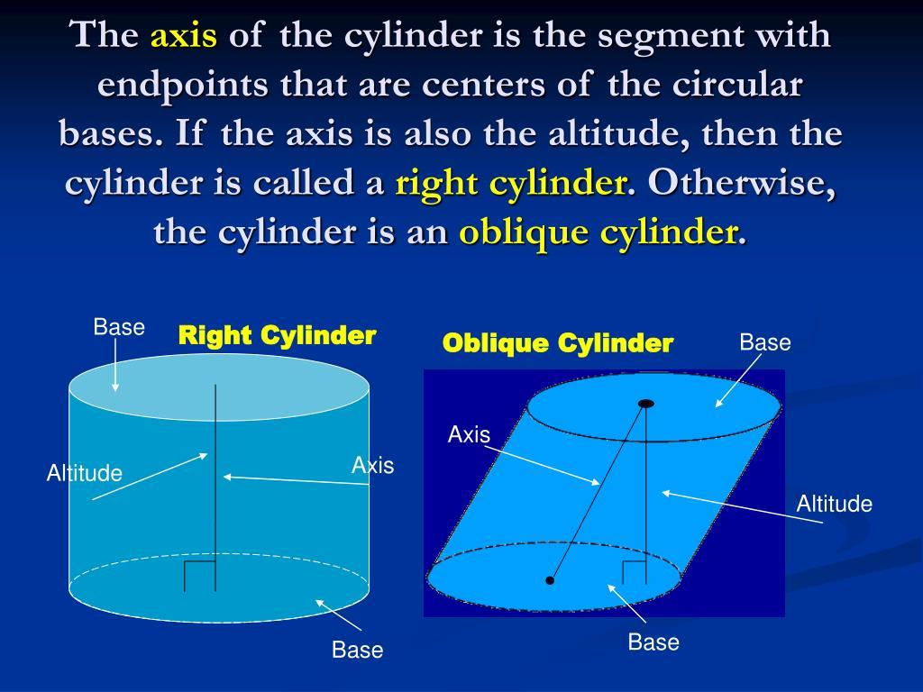
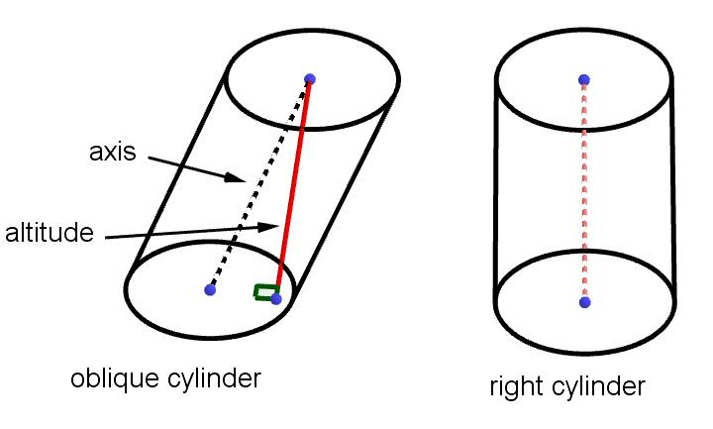
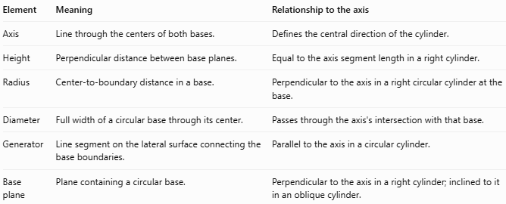
Element | Meaning | Relationship to the axis
Axis | Line through the centers of both bases. | Defines the central direction of the cylinder.
Height | Perpendicular distance between base planes. | Equal to the axis segment length in a right cylinder.
Radius | Center-to-boundary distance in a base. | Perpendicular to the axis in a right circular cylinder at the base.
Diameter | Full width of a circular base through its center. | Passes through the axis's intersection with that base.
Generator | Line segment on the lateral surface connecting the base boundaries. | Parallel to the axis in a circular cylinder.
Base plane | Plane containing a circular base. | Perpendicular to the axis in a right cylinder; inclined to it in an oblique cylinder.

Applications
# Source: AI Source: Provided by: [Data Path: Persons Table -> ID Column: 1, Name_En Column: Motasem Essam] -> From: [ChatGPT] on [7/25/2026]
The axis is useful for understanding and designing cylindrical objects:
- Mechanical engineering: locating rotating shafts, rollers, and cylindrical components.
- Construction: defining the central direction of columns and cylindrical foundations.
- Pipes and tubes: identifying the centerline used for alignment and installation.
- Manufacturing: establishing a reference line for turning, drilling, and machining.
- Geometry: distinguishing right cylinders from oblique cylinders.
- Three-dimensional modeling: positioning and orienting cylinders in coordinate systems.

Key Points
# Source: AI Source: Provided by: [Data Path: Persons Table -> ID Column: 1, Name_En Column: Motasem Essam] -> From: [ChatGPT] on [7/25/2026]
- The axis passes through the centers of the two circular bases.
- It is an imaginary straight line; the axis segment is the portion between the base centers.
- In a right circular cylinder, the axis is perpendicular to the base planes.
- In an oblique circular cylinder, the axis is inclined to the base planes.
- For a right circular cylinder, the axis segment length equals the height.
- For an oblique circular cylinder, the axis segment length is generally greater than the perpendicular height.
- The lateral generators of a circular cylinder are parallel to its axis.

Conclusion
# Source: AI Source: Provided by: [Data Path: Persons Table -> ID Column: 1, Name_En Column: Motasem Essam] -> From: [ChatGPT] on [7/25/2026]
The axis of a cylinder is the central line connecting the centers of its two circular bases. Its orientation determines whether a circular cylinder is right or oblique, and its segment length relates to the cylinder's perpendicular height.
For a right circular cylinder:
$$\boxed{s=h}$$
For an oblique circular cylinder, when $θ$ is the angle between the axis and the perpendicular direction to the bases:
$$\boxed{h=s\cos{θ}}$$

